LAPORAN UJIAN TENGAH SEMESTER

PRAKTIKUM DASAR PEMROGRAMAN

Oleh:

MOCHAMMAD SYAIFUDDIN ZUHRI NIM. 1941720013



PROGRAM STUDI TEKNIK INFORMATIKA

JURUSAN TEKNOLOGI INFORMASI

POLITEKNIK NEGERI MALANG

22 OKTOBER 2019

**LAPORAN UJIAN TENGAH SEMESTER**

**(TIPE SOAL A)**

1. **STUDI KASUS**

User ingin menghitung volume tabung, luas lingkaran, dan rata-rata. Sebelum itu, user diminta untuk memasukkan nilai jari-jari dan tinggi. Kemudian, dilakukan pengecekan, jika nilai yang dimasukkan termasuk bilangan positif, maka akan dilanjutkan proses perhitungan. Tapi jika tidak, maka akan mencetak “Maaf, nilai yang anda masukkan salah. Silahkan masukkan bilangan positif”.

Jika bilangannya yang dimasukkan positif, dilakukan proses perhitungan volume tabung dengan rumus (*phi * r2* * t). Setelah melakukan perhitungan volume tabung, dilanjut dengan luas lingkaran dengan rumus (*phi * r2*). Kemudian menghitung rata-rata dari hasil perhitungan diatas dengan rumus ((volume tabung + luas lingkaran) / 2). Jika hasil dari rata-rata lebih dari 150, maka akan mencetak “Hasil perhitungan : Nilai Tinggi”, selain itu “Hasil perhitungan : Nilai Rendah”.

1. **FLOWCHART**

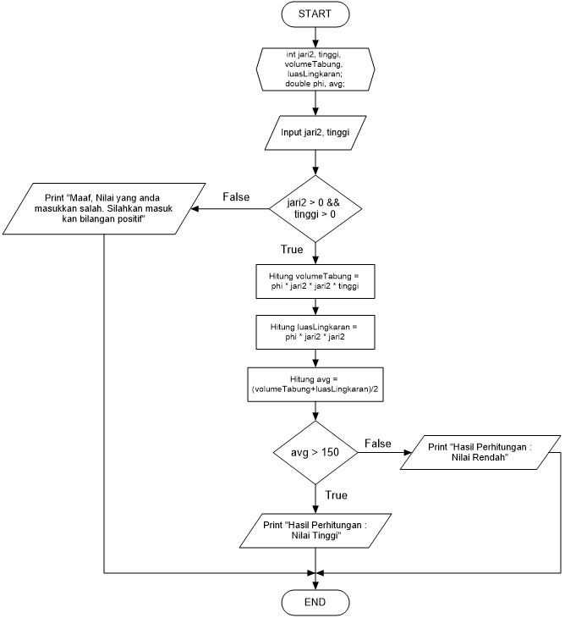

1. **SOURCE CODE**

|  |  |
| --- | --- |
| 1 | package UTS; |
| 2 |  |
| 3 | import java.util.Scanner; |
| 4 |  |
| 5 | public class MidTest { |
| 6 | public static void main(String[] args) { |
| 7 | // Title |
| 8 | System.out.println("********************************************"); |
| 9 | System.out.println("\t\t\t UJIAN TENGAH SEMESTER"); |
| 10 | System.out.println("\t\t\tPRAKTIKUM DASAR PEMROGRAMAN"); |
| 11 | System.out.println("********************************************"); |
| 12 | System.out.println(""); |
| 13 |  |
| 14 | // Identitas Diri |
| 15 | System.out.println("============================================="); |
| 16 | System.out.println("\t\t\t IDENTITAS MAHASISWA"); |
| 17 | System.out.println("-------------------------------------------------------------------------"); |
| 18 | System.out.println("Nama \t\t\t\t: Mochammad Syaifuddin Zuhri"); |
| 19 | System.out.println("Kelas \t\t\t\t: TI 1E"); |
| 20 | System.out.println("NIM \t\t\t\t: 1941720013"); |
| 21 | System.out.println("============================================="); |
| 22 | System.out.println(""); |
| 23 |  |
| 24 | // ===> SOAL MENGHITUNG VOLUME TABUNG DAN LUAS LINGKARAN <=== |
| 25 |  |
| 26 | System.out.println("============================================="); |
| 27 | System.out.println("\tMENGHITUNG VOLUME TABUNG, LUAS LINGKARAN, DAN RATA-RATA"); |
| 28 | System.out.println("============================================="); |
| 29 | System.out.println(""); |
| 30 |  |
| 31 | Scanner input = new Scanner (System.in); |
| 32 |  |
| 33 | // *** Menghitung Volume Tabung *** |
| 34 | System.out.println("-------------------------------------------------------------------------"); |
| 35 | System.out.print("Masukkan Jari-jari \t\t: "); |
| 36 | int jari2 = input.nextInt(); |
| 37 | System.out.print("Masukkan Tinggi \t\t: "); |
| 38 | int tinggi = input.nextInt(); |
| 39 | System.out.println("-------------------------------------------------------------------------"); |
| 40 | System.out.println(""); |
| 41 |  |
| 42 | double phi = 3.14; |
| 43 |  |
| 44 | if (jari2>0 && tinggi>0){ |
| 45 |  |
| 46 | // Perhitungan Volume |
| 47 | int volumeTabung = (int) (phi * jari2 * jari2 * tinggi); |
| 48 |  |
| 49 | System.out.println("-------------------------------------------------------------------------"); |
| 50 | System.out.println("Rumus Menghitung Volume Tabung \t: phi * r * r * t"); |
| 51 | System.out.println("Hasil Volume Tabung \t\t: "+volumeTabung+" cm3"); |
| 52 | System.out.println("-------------------------------------------------------------------------"); |
| 53 | System.out.println(""); |
| 54 |  |
| 55 | // *** Menghitung Luas Lingkaran *** |
| 56 | int luasLingkaran = (int) (2 * phi * jari2); |
| 57 |  |
| 58 | System.out.println("-------------------------------------------------------------------------"); |
| 59 | System.out.println("Rumus Menghitung Luas Lingkaran : phi * r * r"); |
| 60 | System.out.println("Hasil Luas Lingkaran \t\t: "+luasLingkaran+" cm2"); |
| 61 | System.out.println("-------------------------------------------------------------------------"); |
| 62 | System.out.println(""); |
| 63 |  |
| 64 | // *** Menghitung Rata-rata Dua Bangun *** |
| 65 | double avg = (volumeTabung + luasLingkaran)/2; |
| 66 |  |
| 67 | System.out.println("-------------------------------------------------------------------------"); |
| 68 | System.out.println("Rumus Menghitung Rata-rata \t: (Volume Tabung + Luas Lingkaran) / 2 "); |
| 69 | System.out.println("Hasil Rata-rata \t\t: "+avg); |
| 70 | System.out.println("-------------------------------------------------------------------------"); |
| 71 | System.out.println(""); |
| 72 |  |
| 73 |  |
| 74 | // Cek Kondisi Nilai |
| 75 | if (avg>150){ |
| 76 | System.out.println("-------------------------------------------------------------------------"); |
| 77 | System.out.println("Hasil Perhitungan \t\t: Nilai Tinggi"); |
| 78 | System.out.println("-------------------------------------------------------------------------"); |
| 79 | } else { |
| 80 | System.out.println("-------------------------------------------------------------------------"); |
| 81 | System.out.println("Hasil Perhitungan \t\t: Nilai Rendah"); |
| 82 | System.out.println("-------------------------------------------------------------------------"); |
| 83 | } |
| 84 |  |
| 85 | System.out.println(""); |
| 86 | System.out.println("============================================="); |
| 87 | System.out.println("\t\t\tPERHITUNGAN TELAH SELESAI"); |
| 88 | System.out.println("============================================="); |
| 89 | System.out.println(""); |
| 90 |  |
| 91 | } else { |
| 92 | // Jika tidak memenuhi kondisi pertama |
| 93 | System.out.println("============================================="); |
| 94 | System.out.println("Maaf, Nilai yang anda masukkan salah. Silahkan masukkan bilangan positif"); |
| 95 | System.out.println("============================================="); |
| 96 | System.out.println(""); |
| 97 | } |
| 98 | } |
| 99 | } |

1. **CAPTURE SCREEN OUTPUT**
2. **Kemungkinan 1**

* Nilai Jari-jari : 7
* Nilai Tinggi : 15

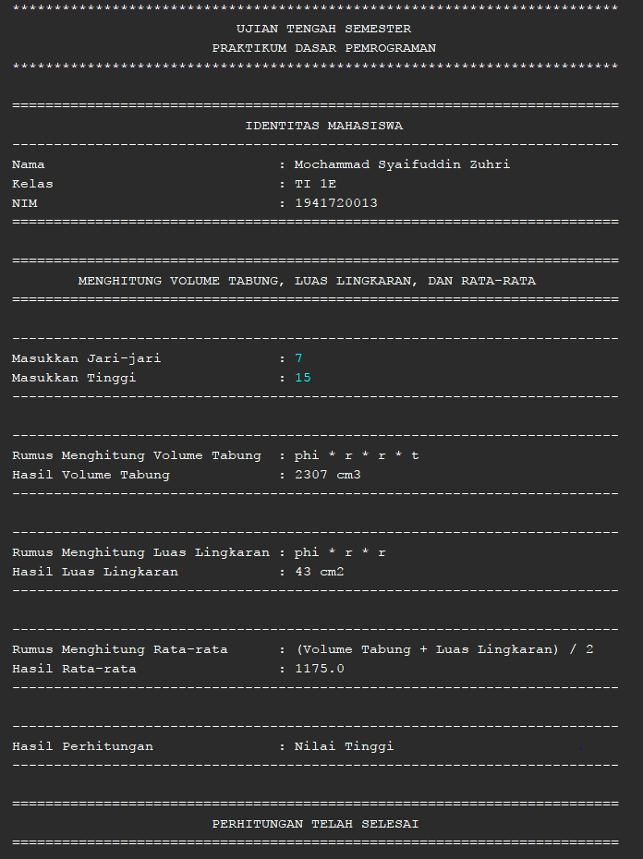

1. **Kemungkinan 2**

* Nilai Jari-jari : 1
* Nilai Tinggi : 3

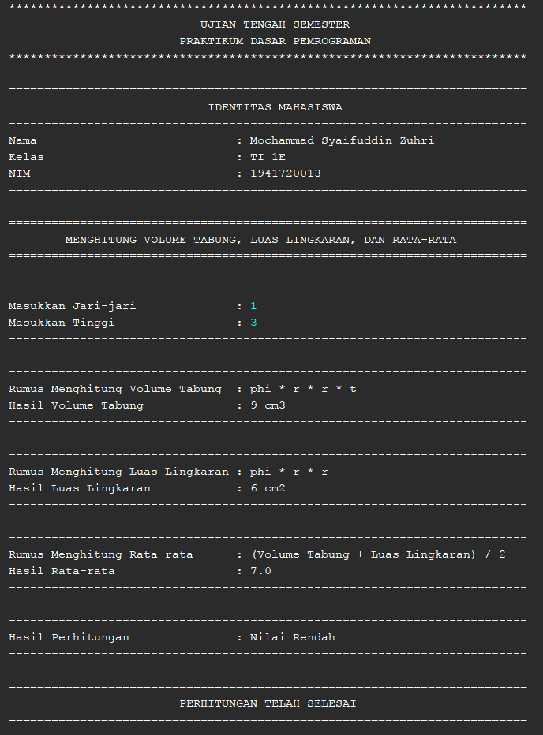

1. **Kemungkinan 3**

* Nilai Jari-jari : 0
* Nilai Tinggi : -3

